Accessing Class Rosters
Questions? Call Registrar at 776.2107, email registrar@yc.edu or visit 1-111
Accessing class rosters:
Login at www.yc.edu
Go to My Services, Faculty, My Class Roster

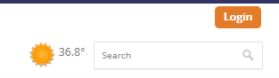
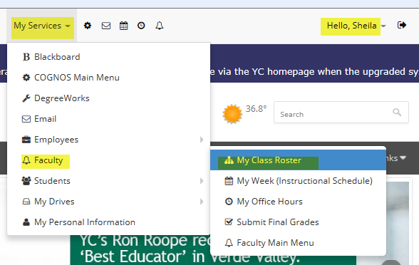
Rosters accessed via www.yc.edu show real time enrollment. Enrollment shifts during the first week of the semester as students drop and add. Please check your rosters as often as needed to verify enrollment. After the first week, it is advisable to check your roster online weekly, so that you know which students have withdrawn. Students who have quit attending but still appear on the roster should be withdrawn by the instructor.
Withdrawing students:
Withdraw students who have stopped participating: enrollmentservices@yc.edu.
- Include the CRN of the course, student name(s) and Ynumber and last date of participation.

Confidentiality of Student Education Records

FERPA (Family Educational Rights and Privacy Act of 1974)

How does FERPA apply to Yavapai College records of Dual Enrollment or JTED students?

- Dual Enrollment or JTED student education records should be treated as any other student education record at Yavapai College.

- The student is enrolled in a post-secondary institution by enrolling in a Yavapai College course, so FERPA rights have transferred to the student.

Yavapai College faculty and staff may NOT discuss dual enrollment education records with the parent - or other third party - unless the student has provided written consent.

“Confidentiality” if noted beside student name on your roster means that this person cannot be referred to as a student to a third party!

Class start/end dates:
- Class start/end dates will display at the top of each roster!
- Dual Enrollment starts early/ends late, to coincide with high school semesters.
- JTED classes follow Yavapai College semester dates.
- A few classes span both the Fall/Spring semesters.

