Strategic Planning Committee Meeting Minutes
Tuesday, January 18, 2022, 9 a.m.- 10:00 a.m., Zoom

Present: Tania Sheldahl, Lauri Dreher, Patrick Burns, Tom Hughes, Tina Redd, Diana Dowling, Mary Talosi, Brian Moultrup, Julie Galgano, Richard Hernandez, Megan Crossfield, and Michael Pierce.

ITEM | ACTION
College 2030- Presentation and Discussion | Tom gave a brief presentation regarding the College 2030 report. The committee discussed the different areas that the report addresses, such as flexibility in learning, the value of education, and holistic student support services. Tom will send the PowerPoint presentation to the committee.
Strategic Goals 2022-2023 | Tom asked the college plans leaders to complete the YC 2022-2023 Strategic Priorities Draft, Sponsor, and KPI columns for each strategic goal. The deadline to complete this task is by the end of January. He will then provide the goals to the President and ELT for review and feedback.  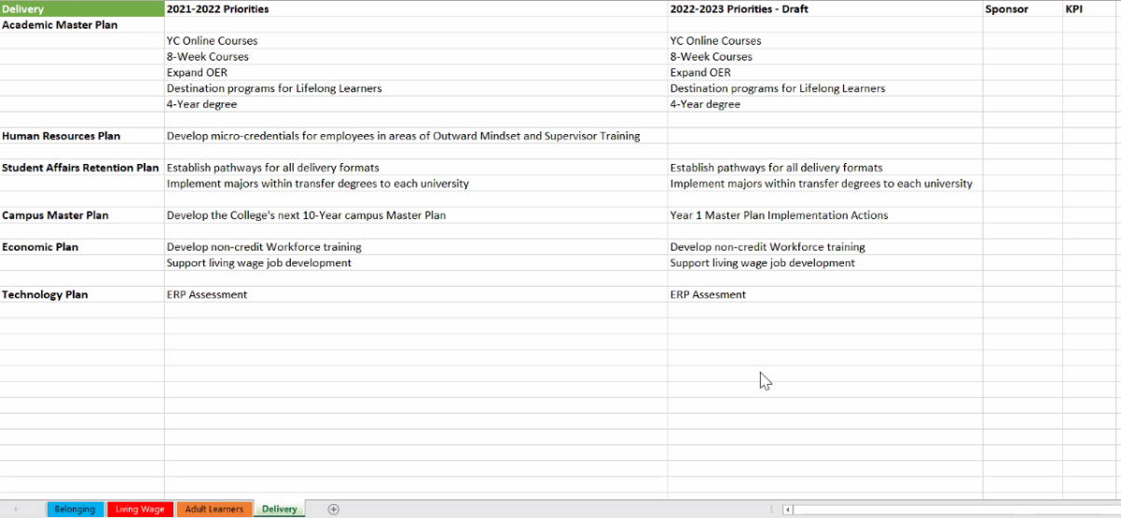
KPI Review and Discussion | Tom reviewed the KPIs with the committee, and it looks as if they are almost complete.  On the Delivery measure, Tom may add “expanding OER.” Tom will reach out to Dr. Rhine to determine if there are some goals. If there are not, Megan and Tom will work together to create a measure.
SPC Reading List | Tom will assign every committee member an article to read and set dates for the presentation.
Zoom Link Recording: https://yavapai.hosted.panopto.com/Panopto/Pages/Viewer.aspx?id=d88652e2-de21-454e-821a-ae2101207e3f&start=6

