Strategic Planning Committee Meeting Minutes
Tuesday, November 16, 2021, 9 a.m.- 10:00 a.m., Zoom

Present: Tania Sheldahl, Lauri Dreher, Patrick Burns, Tom Hughes, Emily Weinacker, Jill Fitzgerald, David Laurence, Michael Pierce, Tina Redd, Diana Dowling, Mary Talosi, Brian Moultrup, Julie Galgano, and Tom Aldridge.

ITEM | ACTION
Fall Committee Goals Review | Fall committee goals for next year are needed by the end of November. Tom will discuss with Dr. Ewell about specific actions and goals that college plans have for next year related to the budget. Dr. Ewell and Dr. Weinacker will talk about the SPC goals with ELT to receive some guidance.
Strategic Actions Brochure | There were two suggestions made regarding the diagram on the brochure.  - Add Student Affairs Retention Plan under the Living Wage.  - Change the color of the diagram on the brochure to match the graph displayed on the SPC website.  Tom will work with marketing on making the changes.
KPI Review and Discussion | The committee had a deep discussion and provided feedback on the Living Wage measures.  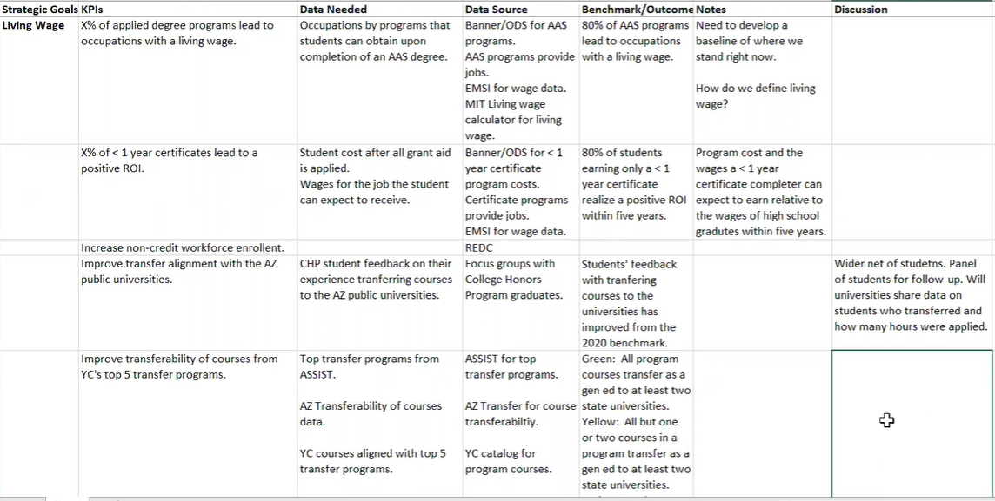
Zoom meeting recording: https://yavapai.hosted.panopto.com/Panopto/Pages/Viewer.aspx?id=d56cdea1-5fc8-4947-a421-ade20123c80e

