Strategic Planning Committee Meeting Minutes
Tuesday, September 7, 2021, 10 a.m.- 11:00 a.m., Zoom
Present: Julie Galgano, Tania Sheldahl, Lauri Dreher, Patrick Burns, Tom Hughes, Clint Ewell, Emily Weinacker, Jill Fitzgerald, Brian Moultrup, Tom Aldridge, Diana Dowling, Mary Talosi, and Ivonne Zuniga.
Absent: Richard Hernandez, David Laurence, and Michael Pierce.

ITEM | ACTION
Welcome and Introductions | Tom welcomed and thanked everyone for attending the meeting. Each member introduced themselves and briefly mentioned their job titles and their roles in the Strategic Planning Committee.
Overview of Planning Process and Timeline | 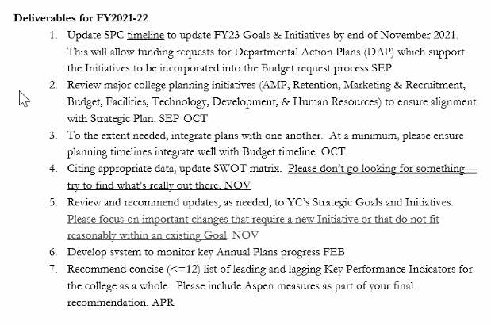  - The committee agreed to change the SPC meetings to 9 a.m. Ivonne will send the updated invite.
Communication  - Brochure  - Poster  - Website Update | - Brochure: create a brochure that lays out the current year we’re in, our strategic goals, and some of the different types of actions we are doing. The brochure would be directed to employees. Tom will create a subcommittee that can assist in the making of the brochure.  - Poster:  - Directed to students and the community.  - Put a QR code on the poster that can take you to a digital brochure.  - Create a digital brochure, so it’s always available.  - Website Update: we will probably see an update on the SPC website by the end of the month.
KPI Subcommittee  - Aspen Award Measures  - MIT Cost of Living | Below are volunteers that would do more profound work on the Aspen Award Measures and MIT cost of living.  - Diana Dowling  - Julie Galgano  - Lauri Dreher  - Tom Hughes

