Strategic Planning Committee Meeting Minutes
Tuesday, November 1, 2022, 9 a.m.- 10:00 a.m., Zoom
Present: Philip Reid, Lauri Dreher, Patrick Burns, Tom Hughes, Megan Crossfield, Diana Dowling, Tania Sheldahl, Frank D’Angelo, Clay Christensen, and Michael Pierce.

ITEM | ACTION
Review and Approve Minutes | The committee voted to approve the minutes.
Technology Plan Presentation (Patrick Burns) | Patrick Burns presented the Technology Plan. The Technology committee created a two-year plan that covers FY2022-2023. The plan has been divided into different areas:  - Application and System and Enhancement  - Information Security  - Technology Support Services (TSS)  - Infrastructure  We are getting to the point where we need to plan for the 2024-2025 plan.  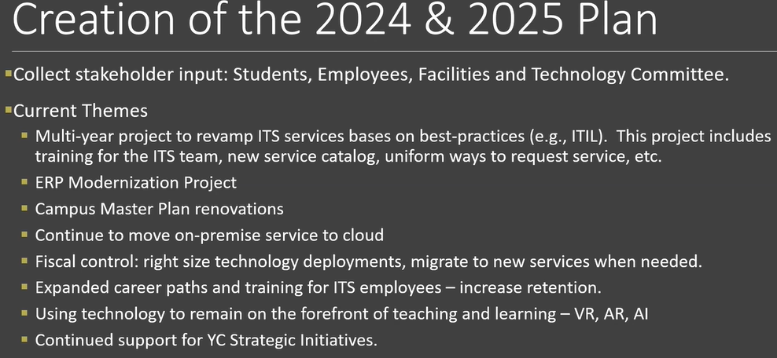
SPC Education  - Future of Higher Education (Philip and Megan) | Megan and Philip summarized the major topics in the article “Future of Higher Education.” The committee briefly discussed the presentation:  Transformation vs. optimization at YC? what does that look like? Of the eight critical capabilities is the most important and critical?
Please find the presentations in the Zoom link: https://yavapai.hosted.panopto.com/Panopto/Pages/Viewer.aspx?id=c3c5016d-7796-409d-997c-af4001247b02&start=245.021159

