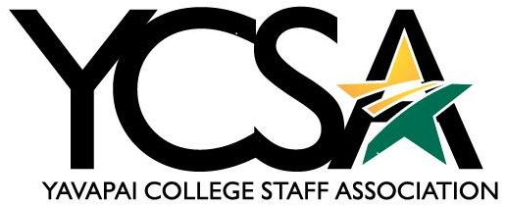

Date: 10/9/2023

General Board Meeting Minutes
Zoom Link: https://yavapai.zoom.us/j/93024174738

1:00 pm-2:00 pm

Attendees: Julie Galgano, Britney Olsen, Jermey Poehnert, Deanna Mooney, Katherine Anderson, Linda Chalcraft, Susanne Baker, Tabitha Fedina, Shelly Gilliam

College Council and College Council Committees update

Julie Galgano
  - College Council 2.0-Dr. Rhine talked about her Afit conference. They did not win the event, but they were runners up. The foundation is working on a budget for IShelter+.
  - IShelter+ video- 61% of YC students have basic needs insecurity. 20% are homeless. YC proposes an A.I. system that will notify Early Alert system for students in need. Ishelter+ will have community resources that students will be made aware of. The board is interested, and people are shocked by the Hope Survey numbers and has brought urgency in the housing issue. Theresa Scott’s role may expand to meet with students for basic needs and housing resources. YCSA may be doing another round for the green bags. They are thinking of giving out bags before winter break and bring them back after winter break. There is a big burst of student need after the Winter break before their financial aid kicks in.
  - Budget Committee- Purpose of the budget committee is to move forward by asking questions.

Ginney Bilbray-Absent
  - Strategic Planning

Shannon Johns- Absent
  - SEM

Janet Nix-Absent
  - ELT Update

Leslie Sparkman-Absent
  - Policy Review

YCSA Committee Updates

Katherine Anderson- Communication- How to request a YCSA Broadcast
  - Planning November newsletter shortly. If there is anything anyone would like included to let her know. YCSA broadcast; if you would like one sent out directions are on the communications page. All information included such as days/time -the committee will review to ensure it is appropriate and isn’t a repeat of information of a Newsflash that hasn’t already gone out. It is focused on staff only and meeting the requirements.

Susanne Barker-Awards
  - Susanne has meet with Wyatt and there were 46 awards given in September. They are now currently collecting awards for October. Susanne is completely out of frames for retirement and needs to order more.

Julie Galgano- Events
  - Winter celebration meeting tomorrow 10/10/2023. They still haven’t decided on the food, but it will be a sit-down meal. They are a young group and trying hard to figure it out. The FEC has been contacted for children to sing at the winter celebration event.

Katherine Anderson-VV Events
  - February Health Sciences Fair is moving it to Prescott Valley Center. The focus is on the students when they are getting ready to graduate. This will be open up to the community members also.
  - Veterans event is October 25th which is an employment job fair. Professional development sessions. Lunch break, then job fair. Veteran affiliated members are welcome to attend. Training on PTSD, mental health, and Navigating benefits. Quest grant covers this event so there will be no cost to attend this event.
  - The 22nd unheard is raising money to install permanent boots. To donate visit yc.edu/22

Deanna Mooney- Professional- Growth-Updated Award Letter
  - 39 people have been approved.
  - 5 applications waiting for approval.
  - $22,395 budget left for the year.
  - Updated professional growth letter for clarification online training vs in-state and out-state requirements.

Shelly Gilliam- Professional Development Day
  - Has not meet yet. Don’t have enough people to pull it off.

Jeremey Poehnert-Engagement
Meet to learn has had two lunches. At the first one there were two attendees and three people attended the second one. Julie Galgano will be covering this upcoming one.

