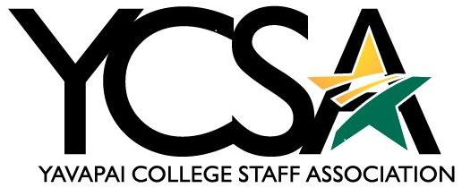

Date January 8, 2024

Agenda
General Meeting 1:00 pm -1:20 pm

Zoom link: https://yavapai.zoom.us/j/93024174738

Attendees: Britney Olsen, Ginney Bilbray, Susanne Baker, Victoria Sweet, Tabitha Fedina, Deanna Mooney, Katherine Anderson, Leslie Sparkman, Shelly Gilliam, Cheryl Williams

College Council and College Council Committees update

Julie Galgano
  - College Council 2.0- No updates
  - Budget- No updates
Ginney Bilbray
  - Strategic Planning- Retreat December 15th at Verde Valley.
Shannon Johns
  - SEM- Absent
Leslie Sparkman
  - Policy Review-Stacey Hilton is now our committee chair. ELT backing away from being chairs of committees. Discussions · Instructional Materials (3.20), Independent Study (3.10), and Faculty Qualification (3.32)/ Procedure 3.32.01. These discussions were tabled until the next meeting.
  - Possibility of bringing back the LEAVE Bank. People can donate time for other employees to use for emergency leave. HR is looking into it. Cannot donate to specific person due to tax liability.
Janet Nix
  - ELT Update-Absent

YCSA Committee Updates

Katherine Anderson -Communication
  - Currently putting together, a list of topics for February Newsletter. Divide up the topics among the committee members. The Newsletter will come out the week of Valentines Day.

Susanne Baker-Awards
  - There have been SAM award nominations put forward and haven’t heard back yet.

Ginney Bilbray- Events
  - Holiday party was amazing. Ducksoup sent out an email saying we were able to help 46 Yavapai College families, 160 presents to YC college students, 3 Verde Valley families, and provided 13 children in the Clarkdale-Jerome School district.
VV Events-None
Deanna Mooney-Professional Growth
  - They ran out of funds in December. They are waiting for more funds to become available. Most applications were for travel.

Shelly Gilliam-Professional Development Day
  - HR is taking over Professional Growth Day. They are deciding between two days in June. A couple of the committee members will remain consultants.

Executive Board Meeting:
1:20pm-2pm

Review nominees before January 26th NOSID. All nominations are due by February 20th, 2024.”

