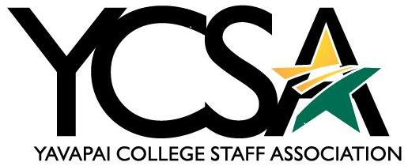

Date 2/12/24

Attendance: Julie Galgano, Deanna Mooney, Susanne Baker, Rebekka Bartels, Cheryl Williams,
Shelley Gilliam, Tabitha Fedina, Leslie Sparkman

Agenda
General Meeting
Zoom link: https://yavapai.zoom.us/j/93024174738

1-2 pm
College Council and College Council Committees update
Julie Galgano
  - College Council 2.0 They are proposing two degrees Business of Applied Science and Bachelor of Science - Computer Science. Still needs to be prepared for curriculum and HLC
  - Eatery sticky notes for food orders is temporary, no catering at this time
  - Camp Friendly Pines
- Staff would like to live there, do they accept pets?
- How would they choose who lives here?
- How long would they be allowed to stay here?
- Is it affordable?
- Will there be ground keepers/property management?
Leslie Sparkman
  - Policy Review- GenEd is changing the age gap
  - 175 updates changing with curriculum
  - Curriculum (3.41) – updated format
  - Faculty Qualification (3.32)/ Procedure 3.32.01- Fac Senate Discussion
  - Mailroom (7.05) – going to College Council
  - Independent Study (3.10) – going out for feedback
  - Severance of Employment FT Fac (2.36) & Grievance Resolution for Faculty (2.37) – Being looked at by Fac Senate

YCSA Committee Updates

Katherine Anderson-Communication
- In the process of creating the February newsletter. Should have it out to the committee mid-week for review, and hopefully out to staff by the end of the week. The snow closure on Friday put a slight delay in the publication.

Susanne Baker-Awards-
- Next retirement is in July 2024
- S.A.M - Monthly awards done quarterly. The first staff winner is Britney Olsen. Still waiting to hear who won from faculty. The winner’s names will go into the pool of employees and will be pulled at convocation for employee of year. Reward is $125.00

Julie Galgano-VV Events
- Years of service would be next, no longer an event sponsored by YCSA. The bricks will still happen with 20 years of service. Possible event could be combined with convocation.

Deanna Mooney-Professional Growth
- One person isn’t going to the conference and will use that money for another person. 74 people got awarded Professional Growth money. The business office asks if you won an award from the fund to please attach the award letter to the TDR.

Shelley Gilliam-Professional Development Day
- HR will handle Professional Development Day. Hailey Green in HR will be in charge and need a few YCSA members as consultants.
- If you have any ideas please submit them to professional development day to ycsa@yc.edu.
- The current idea is, Professional Development Day you will be in-person at the Prescott campus. Possible transportation from outlying campus’ will be provided by YC.

Executive Board Meeting:
3pm-4pm
- Reimagine YCSA
- Change YCSA Board meeting days
- Update Bylaws

