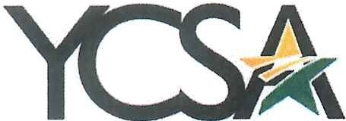
YAVAPAI COLLEGE STAFF ASSOCIATION

Employee Recognition Committee Meeting Notes 2022 / 2023

Date: July 7th, 2022

Meeting Time: 9:00 am

Note Taker: Shannon Johns

In attendance: Jenn Zimmerman, Shannon Johns, Nicole Mangelsdorf, Beckey Massey, Ivonne Zuniga, Wyatt Brannock

Call to Order:
The meeting was called to order at 9:00 am by Jenn Zimmerman.

Minutes

- Jenn Z began the meeting by stating the Employee Recognition Committee's purpose
- Nicole M is updating the High Five nomination form
- Beckey Is updating the list of winners on the website
- The YC Way committee will resume its monthly meetings on July 28th
- There are currently four retirements planned for August, 5 for September, and 1 for October
- The YCSA Employee Recognition page is up to date

Meeting adjourned: 9:38 am by Jenn Zimmerman

Next Meeting: Thursday, August 4th, 2022

Commitment – YCSA is YOU? Thank you for YOU!

