Strategic Planning Committee Meeting Minutes
Tuesday, March 29, 2022, 9 a.m.- 10:00 a.m., Zoom

Present: Tania Sheldahl, Lauri Dreher, Patrick Burns, Tom Hughes, Dr. Emily Weinacker, Brian Moultrup, Julie Galgano, Megan Crossfield, Marnee Zazueta, Dr. Clint Ewell, Richard Hernandez, Diana Dowling, Mary Talosi, Tom Aldridge, and Michael Pierce.

ITEM | ACTION
SPC Deliverables Update | The majority of the SPC deliverables are completed. The next step is to start updating the SWOT matrix and reviewing the YC’s Strategic Goals and Initiatives.
2022-2023 Strategic Priorities  - ELT feedback | ELT provided the following feedback for the 2022-2023 Strategic priorities:  - Different format- by changing the design, it removed the duplicates where strategic priorities were under more than one of the four areas.  - ELT added the columns highlighted in yellow.  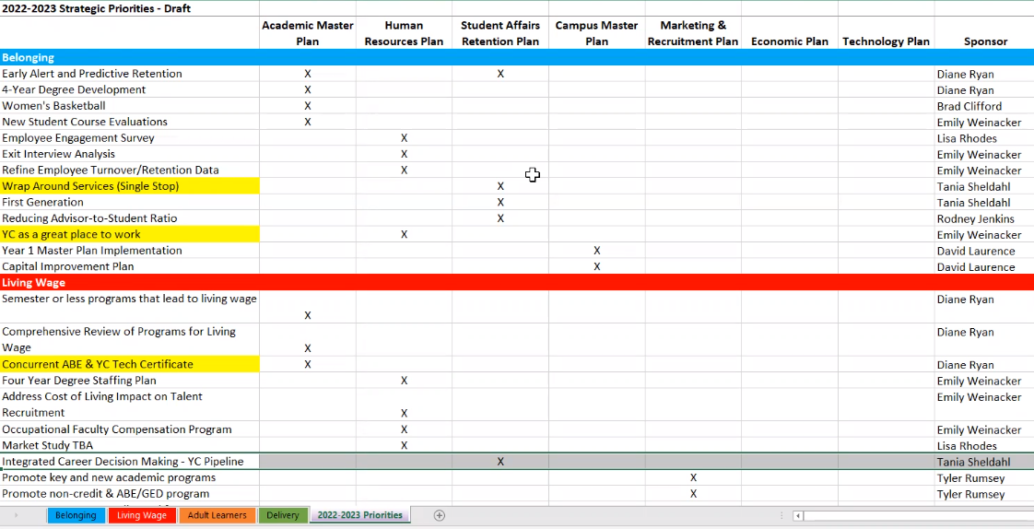
SPC KPIs  - ELT feedback  - KPI communication plan | Tom provided the committee with an analysis of the KPIs. Once the KPIs have been approved, Tom will collaborate with his team to build some visualizations and displays that will be posted on the SPC website. Tom will share the development of those with the committee via email.
SWOT  - Review current SWOT  - Discussion of updates | The committee reviewed the SWOT that last year’s committee did. The group provided the following suggestions to be added.  Strength  - Early College Relationship.  - YCPAC Performing Arts Program vs. YCPAC?  Weaknesses  - Lack of common Canvas shell (look and navigation).  - Too reliant on adjuncts with not providing enough resources to be engaged and involved.  - Not agile in academic processes to remain competitive.  Opportunities  - Recruitment outside the county and state for destination programs.  - Ability to now offer 4-year baccalaureate degrees.  - New funding from Arizona for workforce programs.  Threats  - Resignation and low applicant pool.  - High salaries for occupational program faculty.  For the next SPC meeting, please review the current SWOT matrix and Strategic Plan initiatives and think if there is anything that needs to be added or deleted
Zoom recording: https://yavapai.hosted.panopto.com/Panopto/Pages/Viewer.aspx?id=55adfef0-b702-4556-89d7-ae67011ecc2b

