Strategic Planning Committee Meeting Minutes
Tuesday, October 18, 2022, 9 a.m.- 10:00 a.m., Zoom
Present: Philip Reid, Lauri Dreher, Patrick Burns, Tom Hughes, Megan Crossfield, Clint Ewell, Ginney Bilbray, Heather Mulcaire, Diana Dowling, Richard Hernandez, David Laurence, Tania Sheldahl, and Michael Pierce.

ITEM | ACTION
Review and Approve Minutes | The committee voted to approve the minutes.
Facilities Master Plan Presentation by David Laurence | David Laurence presented the Facilities Master Plan. The Facilities Master Plan committee spent time figuring out how to invest wisely to help the college to continue to grow and thrive.
SPC Education  - YC Enrollment Trends  - 2022-2023 Reading List Assignments  - Plan Presentation Assignments | - Tom Hughes provided a brief overview of the YC Fall Enrollment. The committee wants a report showing ten-year trends for Gen Ed and CTE by discipline and personal interest and a report with retention data. Tom will send the requested reports to the group.  - Please let Tom know if you are unavailable on the day you have been given to present. He will send out the materials to everyone; please read the articles before the meetings.  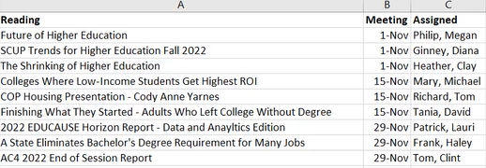  - Tom will send the list below to the group. Please let him know if you have a conflict on the day you have been assigned to present.  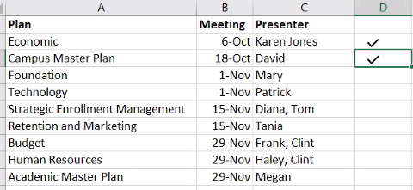
Strengths, Weaknesses, Opportunities, Threats (SWOT)  - Discuss process for this year’s SWOT update | Lauri Dreher, Tom Hughes, and Richard Hernandez will develop the new SWOT.  - Process for this year’s SWOT update.  - Provide Zoom sessions to inform the college about the Environmental Scan and other data, such as enrollment and success.  - Create a short video with a recap and offer a survey to collect feedback.
Zoom link recording: https://yavapai.hosted.panopto.com/Panopto/Pages/Viewer.aspx?id=84793a94-6e02-49fe-b25a-af32011c07ef

