Strategic Planning Committee Meeting Minutes
Tuesday, February 21st, 2023, 9 am- 10:30 am, Zoom.
Present: Lauri Dreher, Patrick Burns, David Laurence, Philip Reid, Tania Sheldahl, Heather Mulcaire, Michael Merica, Diana Dowling, Frank D’Angelo, Clay Christensen, Michael Pierce, Dr. Diane Ryan, and Dr. Clint Ewell.

ITEM | ACTION
Strategic Plan Presentation/Updates | - Diana and Tania gave an overview of the SEM/Retention/Marketing strategic plan.  - Haley provided an update on the 2022-23 HR Strategic Plan.  - Dr. Ewell presented the Yavapai College Foundation Strategic Plan.  - Dr. Diane Ryan presented the Academic Master Plan.
Future Actions | 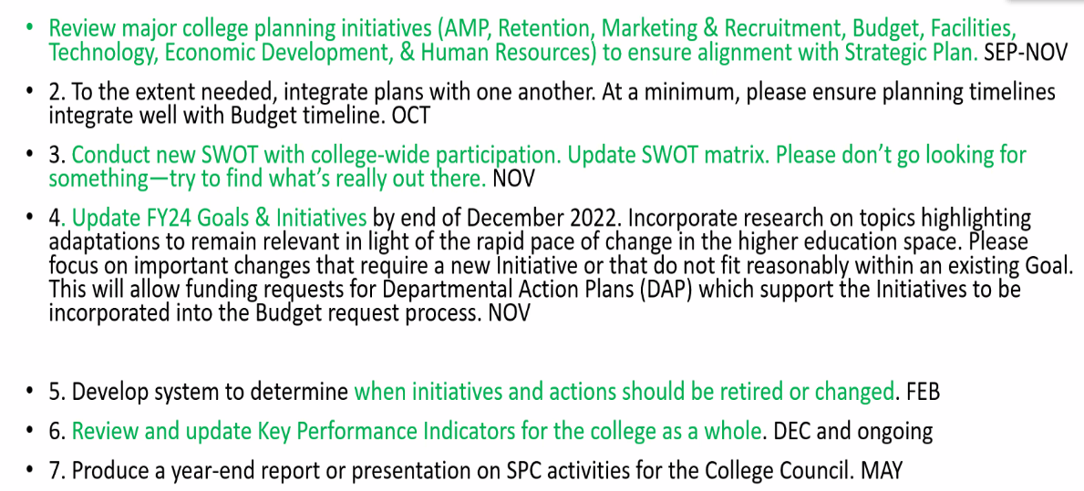
Please find the presentations in the Zoom link: https://yavapai.hosted.panopto.com/Panopto/Pages/Viewer.aspx?id=1c5a669d-acd5-4497-8570-afb0012eba66&start=368.539639

