At Yavapai College, co-curricular activities are defined using a broad definition provided by the Higher Learning Commission (HLC):

Co-Curricular activities are “learning activities, programs and experiences that reinforce the institution’s mission and values and complement the formal curriculum. Examples: Student-faculty research experiences, tutoring, academic advising, professional clubs and organizations, athletics, honor societies, library services, etc” (HLC Criteria for Accreditation Revisions adopted Feb. 2019, effective Sept. 2020).

Using this definition, areas, such as the YC Library and Student Affairs, will use the Co-Curricular Assessment Plan to select one to three activities, programs, and experiences that strengthen students understanding of the College’s Institutional Learning Outcomes (ILOs) each year to evaluate how well students are using their learning outside of the classroom.

There are three Institutional Learning Outcomes:
COMMUNICATION is the ability to effectively develop, express, and support ideas in a variety of mediums.

CRITICAL THINKING includes both the skills and the habit of thinking in a clear, disciplined, open-minded way informed by evidence and observation.

SOCIAL RESPONSIBILITY encompasses diversity awareness, civic and community engagement, as well as historical, global, ethnic, racial and/or gender awareness.

Instructions
The Co-Curricular Assessment Plan and Results form will be used for College areas to plan and assess co-curricular activities, programs, and experiences. There are three sections to be completed by the department.

Section I: Overview Record the sponsoring department of the co-curricular activity, program, or experience; the SLOA Committee member representative or Assessment Liaison who will be collecting the finished reports; and the date the co-curricular report was finished.

Section II: Co-Curricular Assessment Action Plan: Create a plan to gather student learning data to later analysis.
- Write a rationale that outlines the connection between the co-curricular activity(ies), program(s), or experience(s) and ILOs,
- List one to three co-curricular activity(ies), program(s), or experience(s),
- List the associated ILO for each co-curricular activity(ies), program(s), or experience(s),
- Define the targeted audience for the activity, program, or experience,
- Identify the data collection tool to be used,
- Identify the desired benchmark or performance target of learning that should be achieved during the co-curricular activity, program, or experience,
- Determine the timeframe in which to collect the data,
- Identify the person(s) who will be responsible for collecting the data.

Section III: Results Reporting and Analysis Record the data gathered for the co-curricular activity, program, or experience and analysis the results by answering whether or not the students achieved the established benchmark or performance targeted and reflecting on why or why not the benchmark or performance measured was achieved.
- Results and Data: Use this section to record the data collected. This information could be reported in a variety of ways: Results of a rubric or survey, transcript from a Q&A session or focus group, or a question analysis from a quiz.
- Analysis: Using the data from the Results and Data area, write a narrative that discusses the strengths and areas of opportunity about the co-curricular activity, program, experience itself and the student audience learning. Considerations about whether the data collection tool or the co-curricular activity, program, or experience was appropriate or could use alterations can also be discussed.
- Action Plan for Future: Create a plan to offer the co-curricular activity, program, or experience in the future.

Timeline

Creating Learning Outcomes for Co-Curricular Activities, Programs, or Experiences

Co-curricular activities serve two primary functions:
- To Inform: Co-curricular activities that inform introduce the supporting knowledge that students need in order to perform the competency.
- To Practice: Co-curricular activities that support practice require learners to interact with, process, or apply content so that they store what they have learned in long-term memory.

A co-curricular activity, program, or experience should have a learning outcome that is tied to one of the Institutional Learning Outcomes (Communication, Critical Thinking, or Social Responsibility). The co-curricular activity outcome should be specific, measurable, and written in a standard outcome formula.

Outcomes have three components:
- Performance: What should the student be able to do? How will you recognize that learning has happened?
- Conditions: How will the student be able to demonstrate learning?
- Standard: What is an acceptable demonstrated performance target?

When put all together, there is an outcome formula:
“As a result of participating in the [condition] + [audience] will be able to {action} [degree] + [behavior] + [in a method].”

Example: As a result of [participating in Student Officer Training], [the student officers] will be able to {effectively} [conduct a meeting] [by applying Robert’s Rules of Order].

Ultimately, the result of measuring a co-curricular learning outcome should inform the continuous improvement process of the co-curricular activity, program, or experience.

Definitions

Co-Curricular Activities: An activity, program, or experience that supports the institution’s mission and Institutional Learning Outcomes and occurs outside of a formal course.

Data Collection Tool: Determine what instrument will be used to collect data: percentage correct, rubric scores, Likert-type scale on a survey, etc.

Direct Assessment Method: A method that seeks to assess observable student performance. Data collection tools could be a portfolio, pre-/post-tests results.

Formative Assessment Method: Data collected during the program or experiences with the purpose to provide feedback to shape, modify, or improve the program or experience.

Indirect Assessment Method: A method that measures perceptions and opinions of students’ learning. Data collection tools could be self-reported survey data or focus group responses.

Institutional Learning Outcome (ILO): General and measurable outcomes across the student experience. While at least one Institutional Learning Outcome must be assessed for each activity, program, or experience, co-curricular activities might have multiple ILOs embedded within them. Specific ILO definitions are available in the Co-Curricular Assessment Plan and Results instructions.

Performance Targets: What is the desired level of performance that represents students’ success at achieving an outcome?
Examples:
- At least 80% of students will be able to ……….
- The mean rubric score will be 3 or greater on a scale of 1 to 4.

Qualitative Data Collection Type: Narrative data that is useful for understanding the depth and richness of an experience. Examples are written reflections, focus group results, interviews, open-ended questions to surveys.

Quantitative Data Collection Type: Numerical data that is useful for comparing and measuring across individual students or student populations. Examples are rubric scores, checklists, pre-/post-tests, survey questions.

Rationale: Identify the purpose of the co-curricular activity, program, or experience as related to learning outcomes that supports the institutional mission. Consider the driving force and need for the activity, program, or experience.

Responsible/Point Person: Determine who should collect the data. Depending on the Targeted Audience, one person may be able to collect the data, but it may take more if it is a focus group or Q&A.

Summative Assessment Method: Data collected after the activity, program, or experience has been completed. It provides the opportunity to make a judgment on the quality, worth, or compare it to a standard.

Targeted Audience: Define who will be impacted by the co-curricular activity, program, or experience. Examples could include 1st Gen students, TRIO students, YC students at event, Hispanic or other student populations.

Timeframe for Activity: Determine if the activity, program, or experience will be a one-time event or an ongoing event for a week, a month, a semester.

Instructions: Fill out the form sections in light blue.

SECTION I: Overview

Department:
SLOA/Assessment Liaison (email)
Completed by (include date):

SECTION II: Co-Curricular Assessment Action Plan

Co-Curricular Learning Outcome:

Rationale for selecting activity for associated Learning Outcome(s) and ILO(s):

Co-Curricular Activity |  | ILO | Targeted Audience | Data Collection Tool | Performance Target | Timeframe for Activity | Responsible/Point Person
EXAMPLE | Weekly Study Groups | Critical Thinking | All students  1st Gen students | Survey, Focus Group, Q&A Discussion, Quiz, Rubric | If have benchmark, choose +/- target  If no benchmark, aim high! | Semester (formative/summative)  One time event | Daffy Duck
Add your information here:
Add another row for another activity, program, or experience…

SECTION III: Results Reporting (After collecting data)

Results and Data: Report the data collected from the collection tool. Examples could be results of a rubric or survey, transcript from a Q&A session or focus group, or a question analysis from a quiz. This information can also be shared as an attachment to the report.

Example | 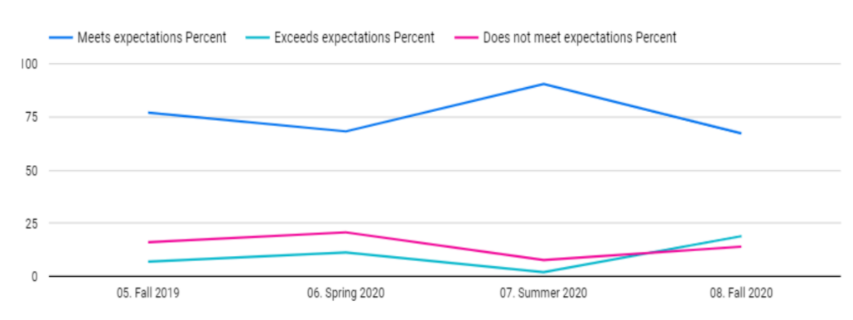

Provide data and results from activity

Analysis (Strengths and Areas of Improvement): Write a narrative that discusses the strengths and areas of opportunity about the co-curricular activity, program, experience itself and the student audience learning.

Action Plan: Based on the data and analysis, outline a plan to offer this co-curricular activity, program, or experience in the future. Consider what changes would need to be incorporated.

DEPARTMENT REFERENCE ADDENDUM

College Mission

Yavapai College enriches our community by providing accessible, quality workforce, transfer, lifelong, and cultural learning opportunities.

College Vision

Yavapai College ensures that Yavapai County is a premier place to learn, work, and live.

Institutional Learning Outcomes

COMMUNICATION is the ability to effectively develop, express, and support ideas in a variety of mediums.

CRITICAL THINKING includes both the skills and the habit of thinking in a clear, disciplined, open-minded way informed by evidence and observation.

SOCIAL RESPONSIBILITY encompasses diversity awareness, civic and community engagement, as well as historical, global, ethnic, racial and/or gender awareness.

