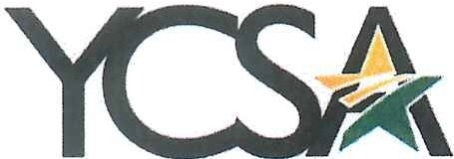
YAVAPAI COLLEGE STAFF ASSOCIATION

Employee Recognition Committee Meeting Notes 2021 / 2022

Date: May 5, 2022

Meeting Time: 9:00AM

Note Taker: Jenn Zimmerman

In attendance: Jenn Zimmerman, Ivonne Zuniga, Beckey Massey, Wyatt Brannock, Nicole Mangelsdorf, (Julie Galgano for the opening of the meeting to introduce and welcome Beckey.)

Call to Order:
Meeting called to order at 9:00 a.m. by Jenn Zimmerman.

Minutes

- High Fives – Beckey has taken over compiling the High Fives, Jenn will send them to printing, and Wyatt sends them electronically. All parties have been extremely busy in the month of April. We will catch up after graduation. Shannon or Nicole will send the completed March winners over to Jerry to update the website. Once April is completed, we will send those over as well. Julie noted that there was a mix up between her and Cassidy Grantham on her high five. We will fix it and resend it. Shannon left an update with Jenn to see if there is a more automated way to issue high fives. Nicole agreed to look into it.
- YC WAY Awards - Are tabled until summer. Did ask Beckey about spring convocation and if it was happening or not. She will get back to us.
- Retirements – Jenn has sent out five frames in the last week to retiring faculty and staff. Each one has requested that they present it to retiree winners. We will request a picture in return for possible addition to HR Happenings. Wyatt will connect to see if that is something HR wants to do. Jenn will check with Lee Ann to see how many more frames we have at the main campus.
- Website updates – High fives need to be updated. YC WAY looks great! We decided to leave retirees off because some do not want that published. Jenn will add Beckey to committee members and provide notes to publish as well.
- Budget – No items to discuss at this time.

Meeting adjourned: 9:27 a.m.

Commitment – YCSA is YOU? Thank you for YOU!

